**NITTE MEENAKSHI INSTITUTE OF TECHNOLOGY**

(AN AUTONOMOUS INSTITUTION, AFFILIATED TO VISVESVARAYA TECHNOLOGICAL UNIVERSITY, BELGAUM, APPROVED BY AICTE & GOVT.OF KARNATAKA



**Application Development using JAVA (18CS45)**

on

**Fee Collection Management**

*Submitted in partial fulfilment of the requirement for the award of Degree of*

*Bachelor of Engineering*

*in*

*Computer Science and Engineering*

*Submitted by:*

|  |  |
| --- | --- |
| NANDAN M  REVANTH N MALLOL  VEERESH | 1NT19CS120  1NT19CS155  1NT19CS213 |
|  |  |
|  |  |

Under the Guidance of

Ms. SHOBHA

DESIGNATION, Dept. of CS&E, NMIT



Department of Computer Science and Engineering

**(Accredited by NBA Tier-1)**

2020-2021

**NITTE MEENAKSHI INSTITUTE OF TECHNOLOGY**

(AN AUTONOMOUS INSTITUTION, AFFILIATED TO VISVESVARAYA TECHNOLOGICAL UNIVERSITY, BELGAUM

, APPROVED BY AICTE & GOVT.OF KARNATAKA)

Department of Computer Science and Engineering

**(Accredited by NBA Tier-1)**



**CERTIFICATE**

This is to certify that the Phase II Report on **Fee Collection Management** is an authentic work carried out by **Nandan M** **(1NT19CS120),** **Revanth N Mallol (1NT19CS155) and Veeresh (1NT19CS213)** abonafide students of **Nitte Meenakshi Institute of Technology**, Bangalore in partial fulfilment for the award of the degree of ***Bachelor of Engineering*** in COMPUTER SCIENCE AND ENGINEERING of Visvesvaraya Technological University, Belagavi during the academic year ***2020-2021.*** It is certified that all corrections and suggestions indicated during the internal assessment has been incorporated in the report.

|  |  |  |
| --- | --- | --- |
| **Internal Guide** |  | **Signature of the HOD** |
|  |  |  |
| Mrs.Shobha P  Assistant Professor, Dept. CSE, NMIT Bangalore |  | Dr.Thippeswamy M. N.  Professor, Head, Dept. CSE, NMIT Bangalore |

**DECLARATION**

We hereby declare that

(i) The project work is our original work

(ii) This Project work has not been submitted for the award of any degree or examination at any other university/College/Institute.

(iii) This Project Work does not contain other persons’ data, pictures, graphs or other information, unless specifically acknowledged as being sourced from other persons.

(iv) This Project Work does not contain other persons’ writing, unless specifically acknowledged as being sourced from other researchers. Where other written sources have been quoted, then:

a) their words have been re-written but the general information attributed to them has been referenced;

b) where their exact words have been used, their writing has been placed inside quotation marks, and referenced.

(v) This Project Work does not contain text, graphics or tables copied and pasted from the Internet, unless specifically acknowledged, and the source being detailed in the thesis and in the References sections.

|  |  |  |
| --- | --- | --- |
| **NAME** | **USN** | **Signature** |
| Nandan M | 1nt19cs120 |  |
| Revanth N Mallol | 1nt19cs155 |  |
| Veeresh | 1nt19cs213 |  |
|  |  |  |

Date: 21-07-2021

**ACKNOWLEDGEMENT**

The satisfaction and euphoria that accompany the successful completion of any task would be incomplete without the mention of the people who made it possible, whose constant guidance and encouragement crowned our effort with success. I express my sincere gratitude to our Principal **Dr. H. C. Nagaraj**, Nitte Meenakshi Institute of Technology for providing facilities.

We wish to thank our HoD**, Dr.Thippeswamy M.N.** for the excellent environment created to further educational growth in our college. We also thank him for the invaluable guidance provided which has helped in the creation of a better project.

I hereby like to thank our ***Mrs.Shobha P, Assistant Professor***, Department of Computer Science & Engineering on her periodic inspection, time to time evaluation of the project and help to bring the project to the present form.

Thanks to our Departmental Project coordinators. We also thank all our friends, teaching and non-teaching staff at NMIT, Bangalore, for all the direct and indirect help provided in the completion of the project.

|  |  |  |
| --- | --- | --- |
| **NAME** | **USN** | **Signature** |
| Nandan M | 1nt19cs120 |  |
| Revanth N Mallol | 1nt19cs155 |  |
| Veeresh | 1nt19cs213 |  |
|  |  |  |

Date: 21-07-2021

**ABSTRACT**

**The purpose of Fees management system is to automate the existing manual system by the help of computerized equipments and fukk-fledged computer software , fulfilling their requirements, son that their valuable data/information can be store for a longer period with easy accessing and manipulation of the same.**

**Student Fees Payment System , can lead to error free , secure, reliable and fast management system.it can assist the concentrate on their other activities rather to concentrate on the record keeping the organization can maintain computerized records without redundant entries.**

**LIST OF TABLES**

**( mysql table data screenshot)**

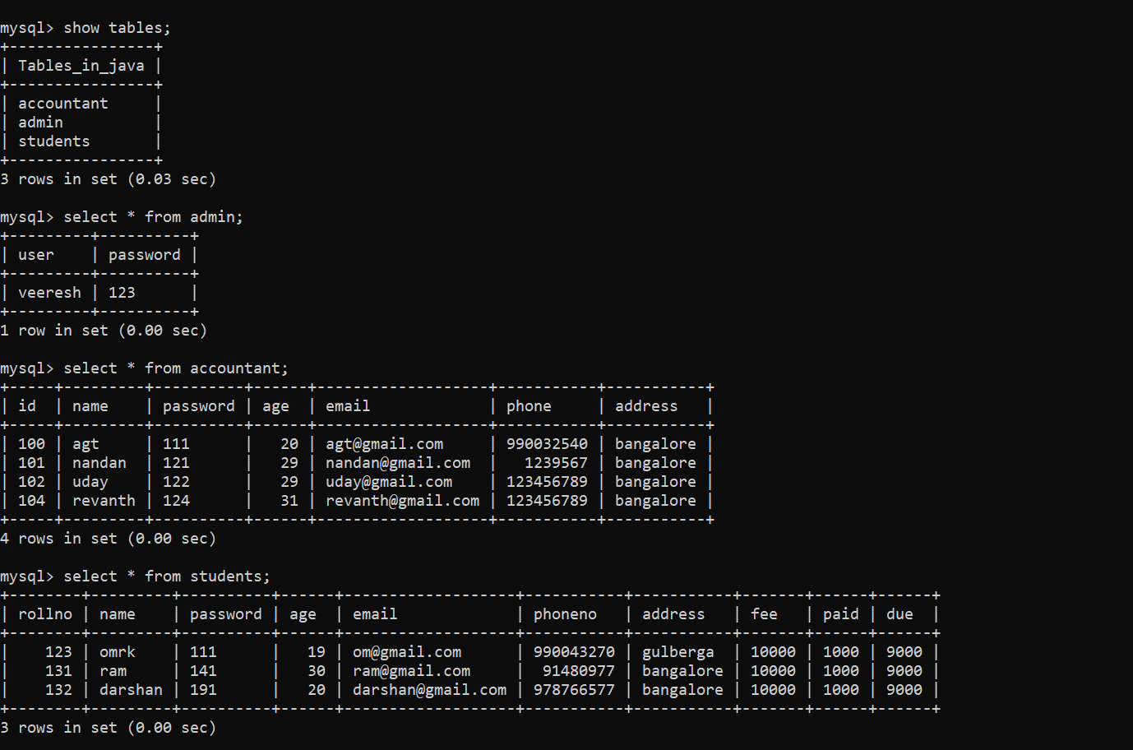

**TABLE OF CONTENTS**

**(screenshot sql tables )**

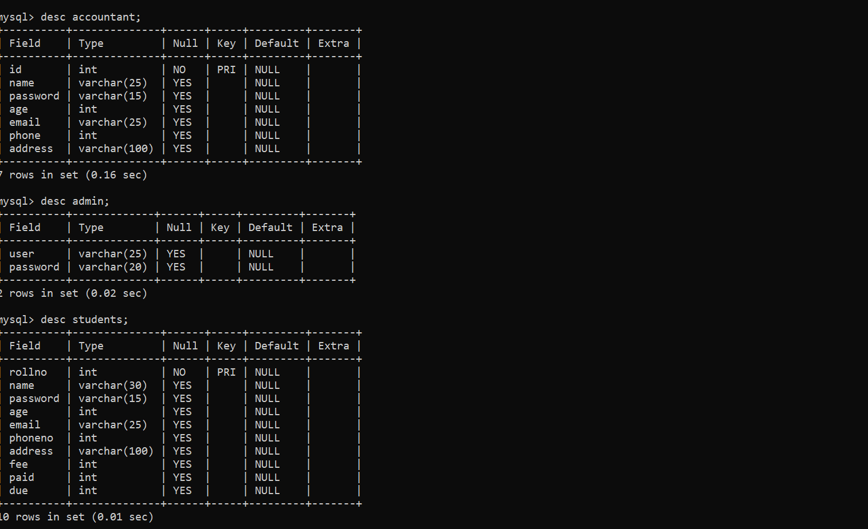

**LIST OF FIGURES**

**( SCREENSHOTS)**

**Two login :- click on any admin or accountant login**

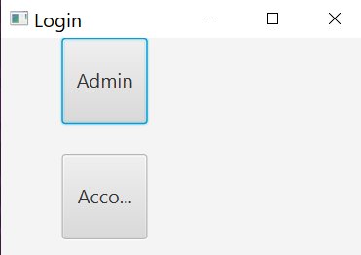

**In admin login : enter admin name and password to log in**

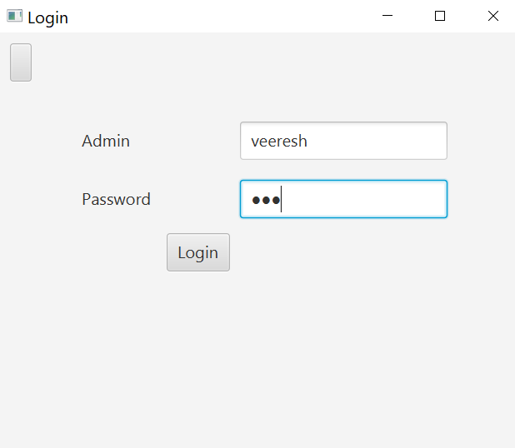

**If entered details details is correct u will be loged in sucessful**

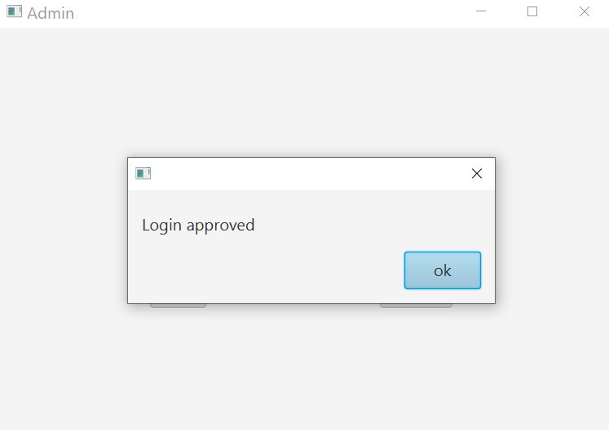

**Inside admin we can add,remove,view accountant and**

**logout easily by clicking on required button**

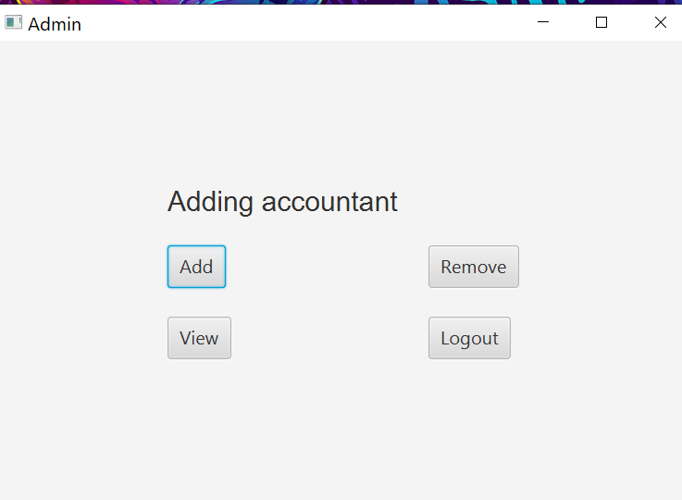

**After clicking on add button admin can add accountant and his/her details**

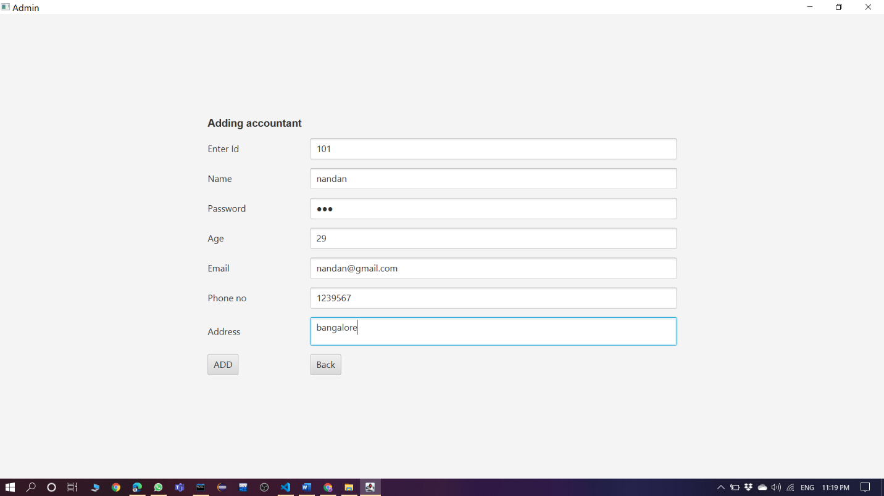

**After entering the record ,it will display successfully added record**

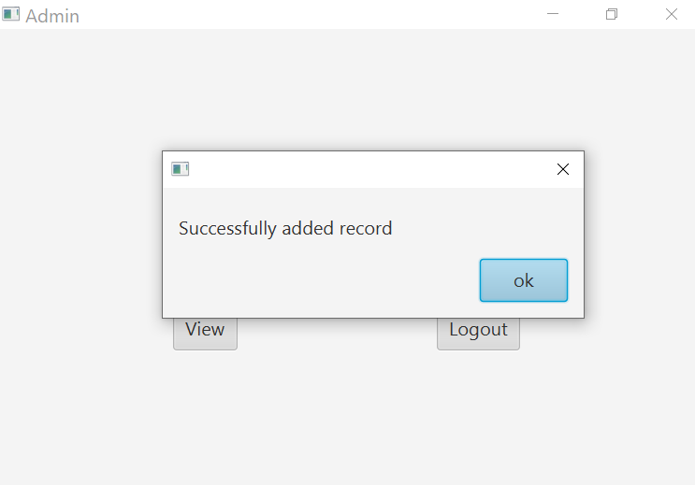

**Admin can remove accountant by entering accountant id and name**

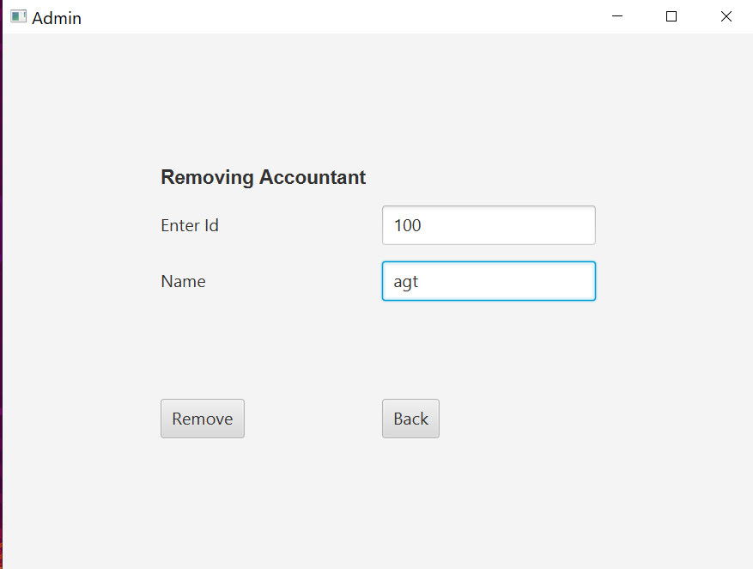

**After deleting ,it will display successfully deleted record**

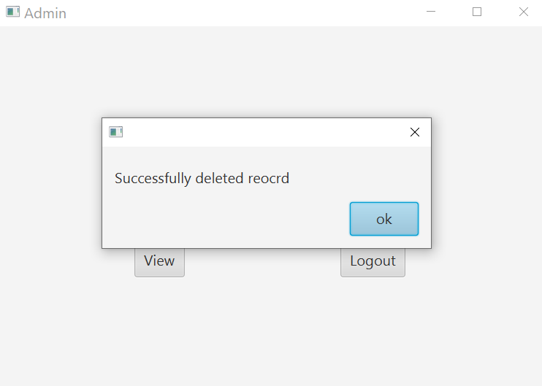

**Admin can view accountant details ,by clicking on view button**

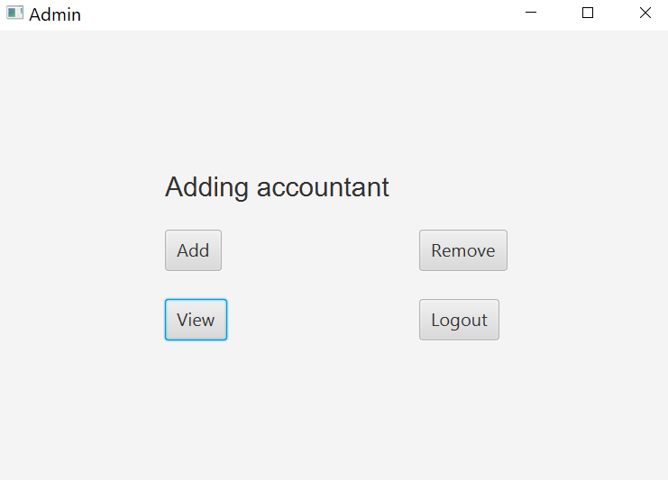

**Admin can logout easily by clicking on logout button**

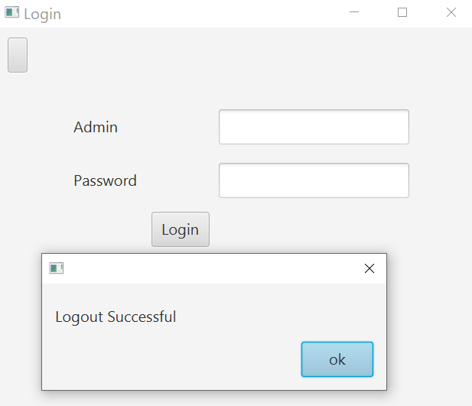

**To login into the accountant account ,accountant need to enter name and password**

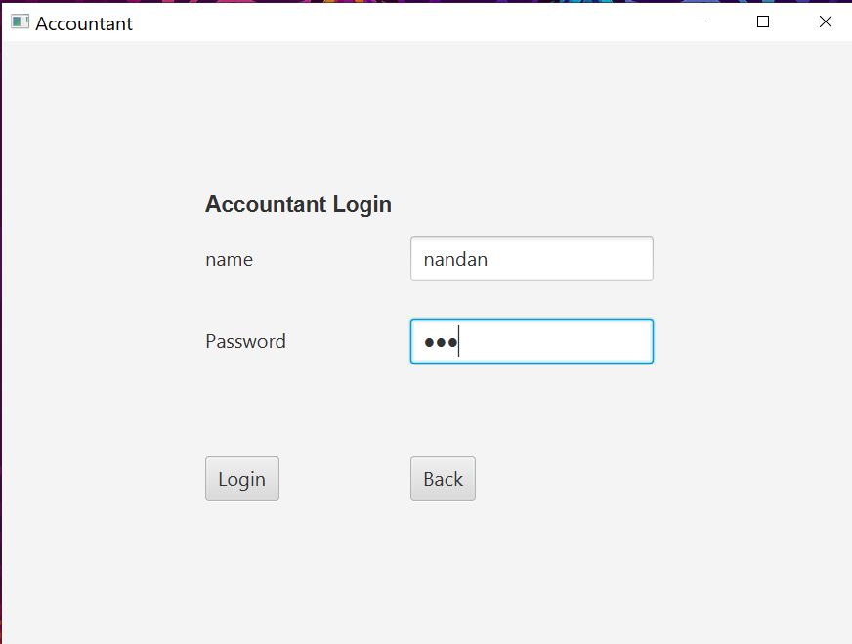

**If entered name and password is correct,it will let accountant to login**

**otherwise it won’t let accountant to login**

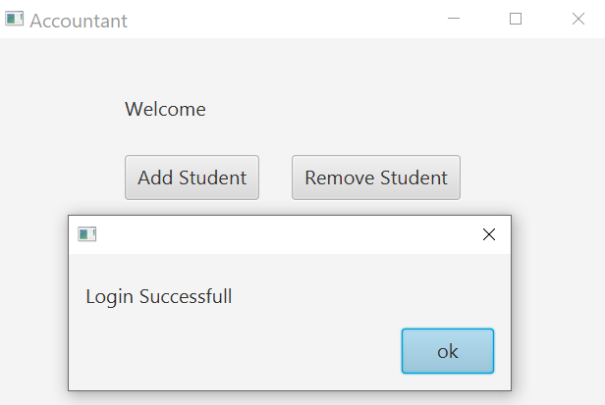

**After entering correct name and password ,**

**accountant can add,remove,edit and view the student details**

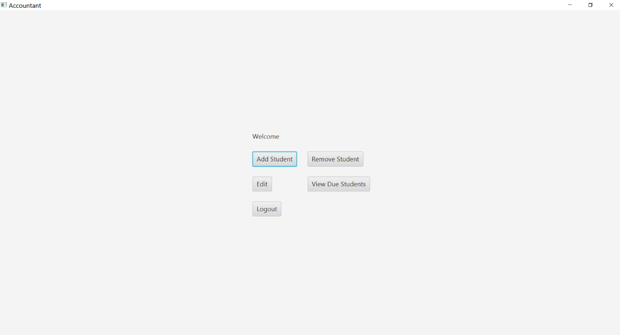

**Accountant can add student details and amount of fee he/she is going to pay**

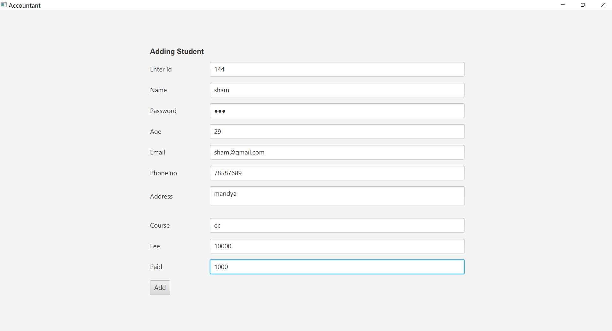

**The details will be added successfully**

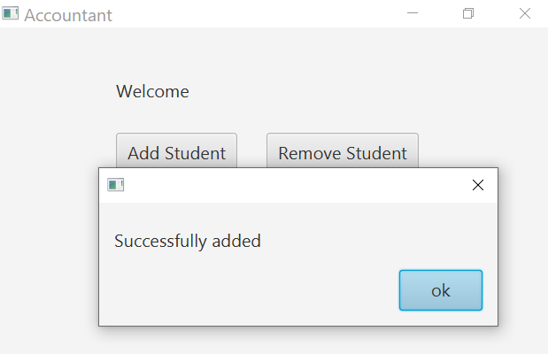

**The account can remove student details just by entering the id and name**

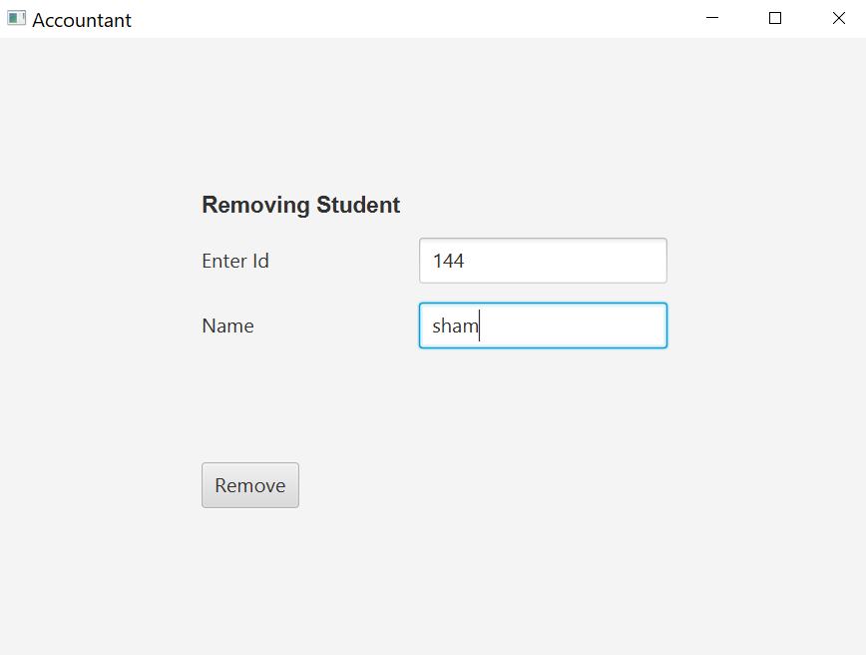

**After deleting the student ,it will display successfully deleted**

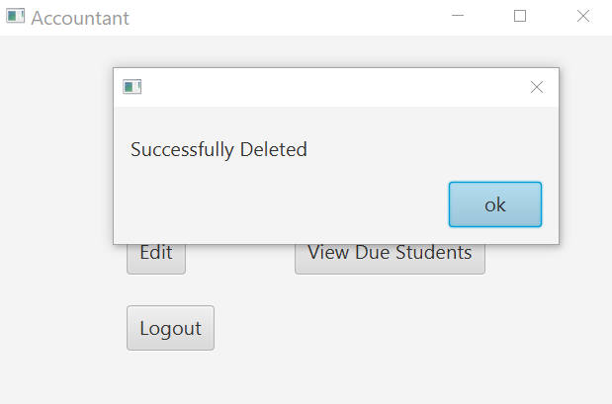

**Accountant can update the student details if student need to pay amount or edit details**

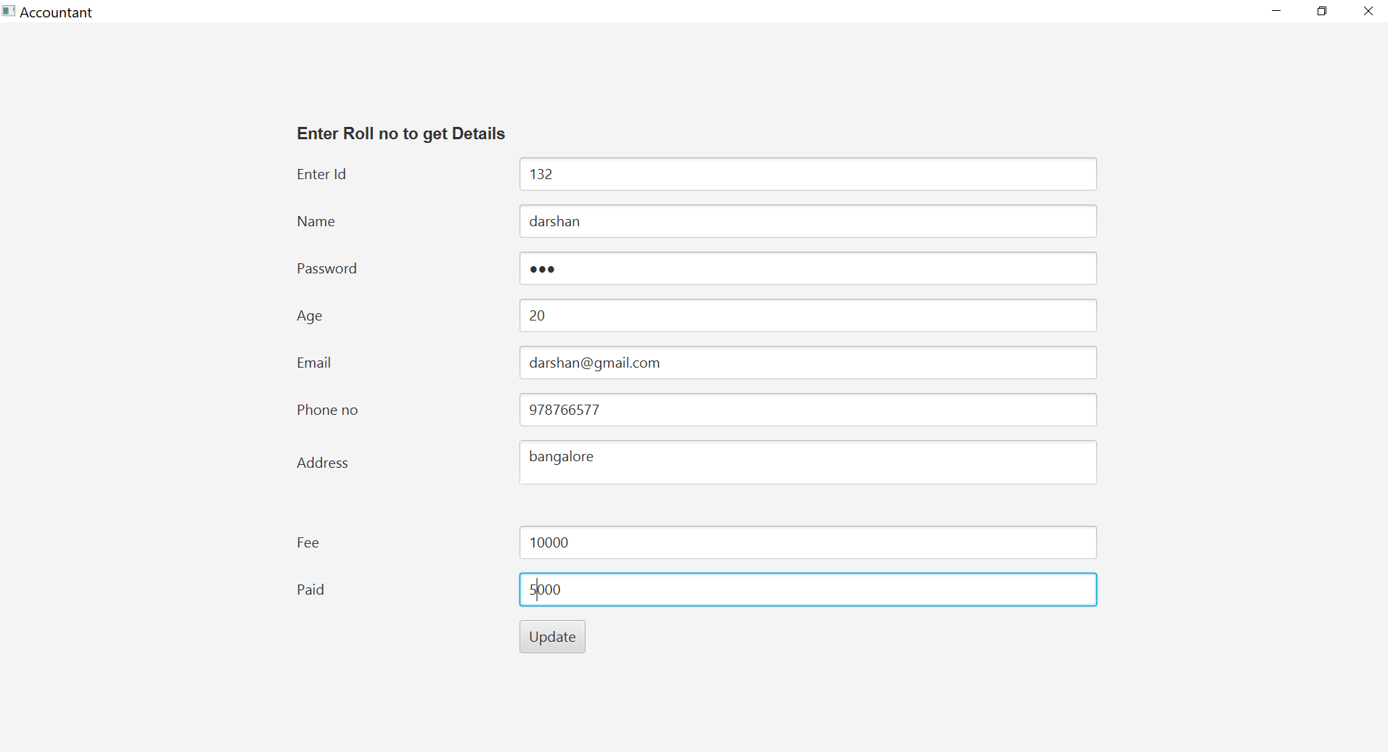

**After entering the details ,it will display successfully updated**

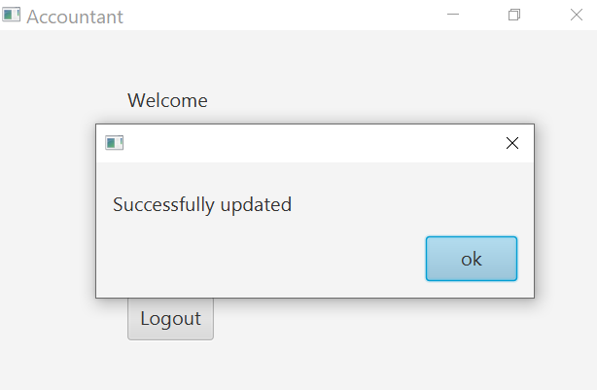

**Accountant can view due details by clicking on below button**

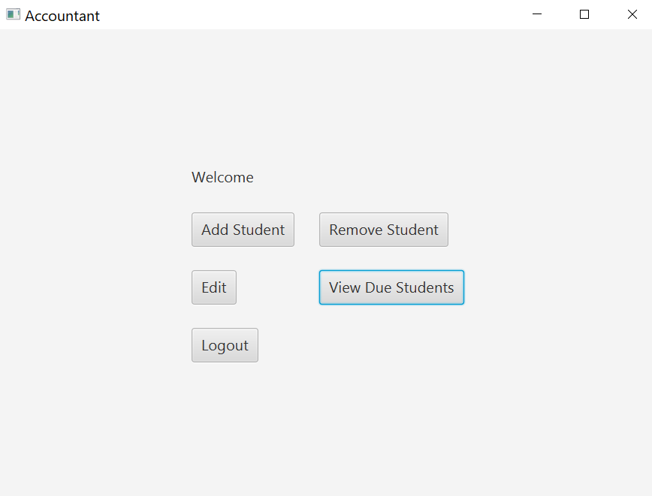

**CODE** **IMPLEMENTATION**

**App.java**



**Admin.java**



**Adminlogin.java**



**Accountant.java**



**Accountantlogin.java**



**Details**



\

**INTRODUCTION**

**The "Student Fee Management system" has been developed to override the problems prevailing in the practicing manual system. This software is supported to eliminate and in some cases reduce the hardships faced by this existing system. Moreover this system is designed for the particular need of the company to carry out operations in a smooth and effective manner.**

**The application is reduced as much as possible to avoid errors while entering the data. It also provides error message while entering invalid data. No formal knowledge is needed for the user to use this system. Thus by this all it proves is user-friendly. Student Fees Payment System, as described above, can lead to error free, secure, reliable and fast management system. It can assist the user to concentrate on their other activities rather to concentrate on the record keeping. Thus it will help organization in better utilization of resources.**

**Every organization, whether big or small, has challenges to overcome and managingthe information of Course, Student, Semester, Payment, Fees. Every Student Fees Payment System has different Student needs, therefore we design exclusive employee management systems that are adapted to your managerial requirements. This is designed to assist in strategic planning, and will help you ensure that your organization is equipped with the right level of information and details for your future goals. Also, for those busy executive who are always on the go, our systems come with remote access features, which will allow you to manage your workforce anytime, at all times. These**

**systems will ultimately allow you to betfer manage resources**.

**SYSTEM REQUIREMENTS SPECIFICATIONS**

**JAVA ECLIPSE IDE**

**JAVA FX JAR FILES**

**JAVA DATABESE CONNECTOR AND JAR FILES**

**MY SQL SERVER CLIENT**

**CONCLUSIONS**

**From this system we can conclude that it provides better fee management system and also lot of convince than the old system. This process is very fast data can be easily entered lot of time is also saved. It is very easy to understand and this program can be used anywhere based on requirement.**

**REFERENCES**

**1.Wikipedia**

**2.Jenkov tutorials**

**3.oracle.docs**

**4.E-book and below part…**

**Electronic Documents**

**E-books**

[1] L. Bass, P. Clements, and R. Kazman, Software Architecture in Practice, 2nd ed. Reading, MA: Addison Wesley, 2003. [E-book] Available: Safari e-book.

**Article in Online Encyclopaedia**

[2] D. Ince, “Acoustic coupler,” in A Dictionary of the Internet. Oxford University Press, [online document], 2001. Available: Oxford Reference Online, http://www.oxfordreference.com [Accessed: May 24, 2007].

**Journal Article Abstract (accessed from online database)**

[1] M. T. Kimour and D. Meslati, “Deriving objects from use cases in real-time embedded systems,” Information and Software Technology, vol. 47, no. 8, p. 533, June 2005. [Abstract]. Ava ilable: ProQuest, http://www.umi.com/proquest/. [Accessed November 12, 2007].

**Journal Article in Scholarly Journal (published free of charge on the Internet)**

[2] A. Altun, “Understanding hypertext in the context of reading on the web: Language learners’ experience,” Current Issues in Education, vol. 6, no. 12, July, 2005. [Online serial]. Available: http://cie.ed.asu.edu/volume6/number12/. [Accessed Dec. 2, 2007].

**Newspaper Article from the Internet**

[3] C. Wilson-Clark, “Computers ranked as key literacy,” The Atlanta Journal Constitution, para. 3, March 29, 2007. [Online], Available: http://www.thewest.com.au. [Accessed Sept. 18, 2007].

**Internet Documents**

**Professional Internet Site**

[1] European Telecommunications Standards Institute, “Digital Video Broadcasting (DVB): Implementation guide for DVB terrestrial services; transmission aspects,” European Telecommunications Standards Institute, ETSI-TR-101, 2007. [Online]. Available: http://www.etsi.org. [Accessed: Nov. 12, 2007].

**Journal Articles**

**Article in Journal (paginated by annual volume)**

[8] K. A. Nelson, R. J. Davis, D. R. Lutz, and W. Smith, “Optical generation of tunable ultrasonic waves,” Journal of Applied Physics, vol. 53, no. 2, Feb., pp. 1144-1149, 2002.

**Books**

**Single Author**

[1] W. K. Chen, Linear Networks and Systems. Belmont, CA: Wadsworth Press, 2003.

**Edited Book**

[2] J. L. Spudich and B. H. Satir, Eds., Sensory Receptors and Signal Transduction. New York: Wiley-Liss, 2001.

**Selection in an Edited Book**

[3] E. D. Lipson and B. D. Horwitz, “Photosensory reception and transduction,” in Sensory Receptors and Signal Transduction, J. L. Spudich and B. H. Satir, Eds. New York: Wiley-Liss, 2001, pp-1-64.

**Three or More Authors**

[4] R. Hayes, G. Pisano, and S. Wheelwright, Operations, Strategy, and Technical Knowledge. Hoboken, NJ: Wiley, 2007.

**Manual**

[6] Bell Telephone Laboratories Technical Staff, Transmission System for Communication, Bell Telephone Lab, 2005.

**Technical Report**

[8] K. E. Elliott and C. M. Greene, “A local adaptive protocol,” Argonne National Laboratory, Argonne, France, Tech. Report. 916-1010-BB, 7 Apr. 2007.

**Patent/Standard**

[9] K. Kimura and A. Lipeles, “Fuzzy controller component,” U. S. Patent 14, 860,040, 14 Dec., 2006.

Thank you